**DFINAL Exam: DATABASE**

**WEP 2024**

**{3h 00}**

25 JAN 2023

**RULES:**

* Chatting and talking to other students is forbidden
* You are allowed to use PhpMyAdmin or VSCode or any other software. But it is not required
* Write (copy/paste) your answer below the question. Do not screenshot.

**HOW DO I SUBMIT THE EXAM?**

* Save this document as a yourfullname.PDF file
* In Google Classroom, attach this file to submit.

|  |  |
| --- | --- |
| **EXERCISES** | **POINTS** |
| THOERYS | 20 |
| EXERCISE 1 | 20 |
| EXERCISE 2 | 20 |
| EXERCISE 3 | 20 |
| EXERCISE 4 | 20 |
| EXERCISE 5 | 20 |
| **TOTAL** | **100** |

# Exercise 03 (20 points) Basic SQL Query

Write SQL query to create tables that have in Entity Relational Diagram (ERD) below:

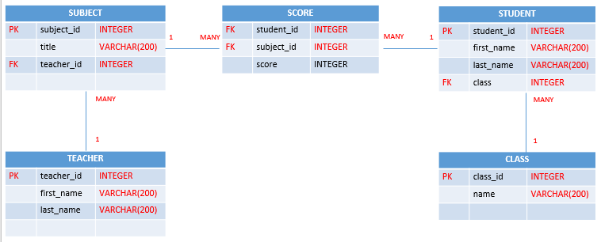

**Your Query:**

|  |
| --- |
| **create database classroom_db;**  **create table teachers(**  **-> teacher_id int not null primary key auto_increment,**  **-> first_name varchar(200),**  **-> last_name varchar(200));**  **create table classes(**  **-> class_id int not null primary key auto_increment,**  **-> name varchar(200));**  **create table students(**  **-> student_id int not null primary key auto_increment,**  **-> first_name varchar(200),**  **-> last_name varchar(200),**  **-> class_id int not null,**  **-> foreign key (class_id) references classes(class_id));**  **create table subjects(**  **-> subject_id int not null primary key auto_increment,**  **-> title varchar(200),**  **-> teacher_id int not null,**  **-> foreign key (teacher_id) references teachers(teacher_id));**  **create table scores(**  **-> student_id int not null,**  **-> subject_id int not null,**  **-> score int,**  **-> foreign key (student_id) references students(student_id),**  **-> foreign key (subject_id) references subjects(subject_id));** |

# Exercise 04 (20 points) SQL Query Select

***Important****: Import database name “database_final_exam.sql” into your databasae.*

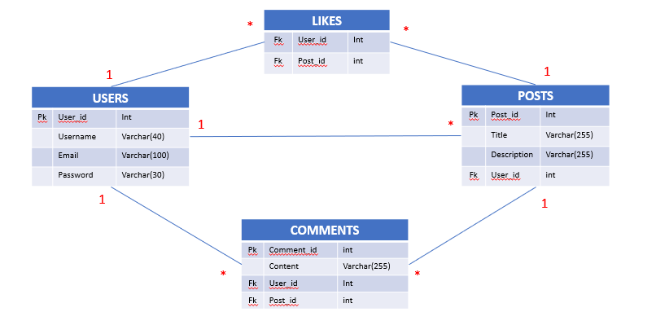

**Q1 – (10 POINTS):** Write a SQL statement to display all POSTS for the user named “**Rady Y**”

**Expected result:**

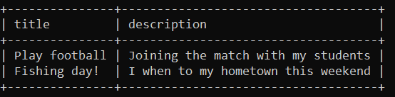

**Your Query:**

|  |
| --- |
| **select posts.title,posts.description from (posts**  **-> INNER JOIN users ON users.user_id = posts.user_id);** |

**Q2 – (10 POINTS):** Write a SQL statement to display the username of who likes on many posts.

**Expected result:**

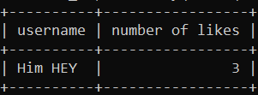

**Your Query:**

|  |
| --- |
| **select users.username,likes.post_id as 'number of likes' from( users**  **-> INNER JOIN users ON users.user_id = likes.user_id) where user_id='4';** |